- list 3 real-world devices in your home or college that use SMPS (Switched Mode Power Supply) and 2 devices that use UPS (Uninterruptible Power Supply), explaining in one line why each device needs that type of power supply.

~ Real-World Devices That Use SMPS and UPS
Power supplies are an essential part of every electronic device. They ensure that devices receive the correct type and amount of electrical power needed to operate safely and efficiently. Two of the most common power systems are Switched Mode Power Supply (SMPS) and Uninterruptible Power Supply (UPS). An SMPS converts high-voltage AC electricity from the wall outlet into the low-voltage DC power required by electronic components while minimizing energy loss. A UPS, on the other hand, provides backup power using a battery whenever the main electricity supply fails, allowing devices to continue operating for a short period or to shut down safely.

. Switched Mode Power Supply (SMPS)
An SMPS uses high-frequency electronic switching (typically tens to hundreds of kilohertz) to convert wall-outlet alternating current (AC) into steady direct current (DC). Unlike older linear supplies that waste extra energy as heat, an SMPS dynamically adjusts its switching pulse width to stay cool, compact, and energy-efficient.

1. Desktop PC Power Supply Unit (PSU)
- Why it needs an SMPS: A modern PC processor and graphics card require huge amounts of current at strict, distinct DC voltages (+12V for high-draw hardware, +5V and +3.3V for microcontrollers and RAM).
- The technical benefit: An SMPS dynamically adjusts power output based on live demand—whether your PC is idling on the desktop or pulling 600 Watts while rendering a 3D scene—maintaining ultra-stable voltages so component clock speeds don't crash or destabilize.

2. Smartphone & Laptop Fast Chargers
- Why it needs an SMPS: To convert high-voltage wall AC (100–240V) down to low DC voltages (5V to 20V) inside a pocket-sized brick without melting.
- The technical benefit: Traditional power supplies used heavy iron transformers that generated immense waste heat. By switching at ultra-high frequencies (and using modern materials like Gallium Nitride / GaN), SMPS circuits shrink the required transformer down to the size of a thimble, keeping chargers portable, light, and cool to the touch.

3. Wi-Fi Routers and Fiber ONTs
- Why it needs an SMPS: Networking hardware runs continuously 24 hours a day, 365 days a year, requiring steady DC power with minimal energy overhead.
- The technical benefit: Because routers are constantly powered on, using a low-efficiency power supply would waste continuous electricity and degrade components over time from excess heat. An SMPS provides tight voltage regulation to keep network processors from resetting during minor power sags while maintaining high energy efficiency.

2. Uninterruptible Power Supply (UPS)
A UPS combines a battery array, a battery charger, and an inverter to store electrical energy continuously. When the mains power fails, sags, or surges, the UPS instantaneously supplies continuous power to attached electronics.

1. College Data Centers & Server Rooms
- Why it needs a UPS: Servers host student portals, research databases, campus Wi-Fi, and critical cloud infrastructure that cannot tolerate even a millisecond of interruption.
- The technical benefit: Data centers typically use Online Double-Conversion UPS systems. These continuously run power through the battery circuit, resulting in zero millisecond transfer time when grid power drops. This prevents database corruption, hardware damage, and server reboots, bridging the crucial gap until emergency backup generators kick in.

2. Computer Lab & Research Workstations
- Why it needs a UPS: Desktop PCs lack internal
- batteries. A sudden blackout cuts power instantly, wiping unsaved RAM data and risking drive corruption during active file read/write cycles.
- The technical benefit: A Line-Interactive UPS provides both Automatic Voltage Regulation (AVR) to smooth out minor brownouts/surges without draining the battery, and 10 to 15 minutes of emergency power during a total blackout—giving students and researchers enough time to save work, finish running scripts, and perform a graceful system shutdown.

- Draw and label a diagram showing the main internal components of a typical SMPS unit found in a desktop PC, including AC input, rectifier, transformer, and DC output sections. You can hand-draw and upload a photo, or use any free diagram tool like draw.io.
Here is a detailed block diagram of a typical Desktop PC Switched-Mode Power Supply (SMPS). It shows the critical signal flow, energy conversion stages, and isolation boundaries from the 120/240V AC Mains input to the final regulated DC voltage rails.
You can save this image to your computer, use it for study, or print it out as needed.
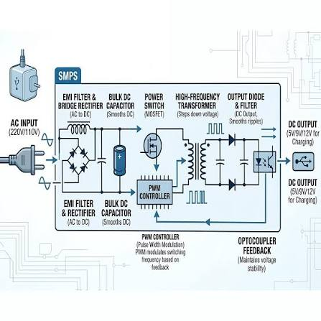

- Take photos or find clear images online of the following power connectors: ATX 24-pin motherboard connector, SATA power connector, Molex connector, and PCIe 6/8-pin connector. For each, write its name, the devices it powers, and one safety tip for connecting/disconnecting it.

1. ATX 24-Pin Main Power Connector 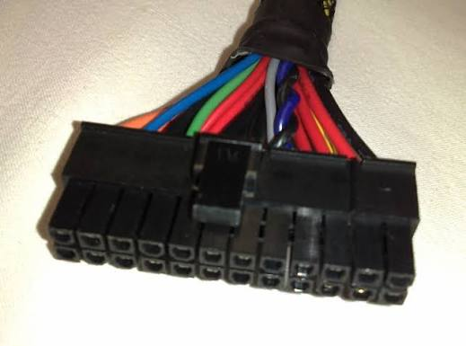
- Name: ATX 24-Pin Main Power Connector (or 20+4 pin connector)
- Devices Powered: Mainboard/Motherboard (delivering power to the chipset, RAM, PCIe slots, integrated audio, networking, and onboard controllers).
- Safety Tip: Always press and hold the plastic retaining latch on the side of the connector to release the safety lock before pulling; pull firmly on the plastic connector housing itself rather than yiggling or yanking on the individual wires to avoid pulling pins out of the header.

2. SATA Power Connector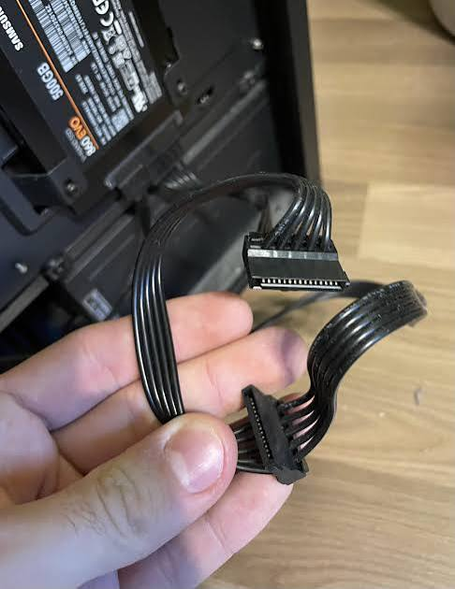
- Name: SATA Power Connector (15-pin)
- Devices Powered: 2.5-inch and 3.5-inch SATA Hard Disk Drives (HDDs), SATA Solid-State Drives (SSDs), Optical Drives (CD/DVD/Blu-ray), fan hubs, and RGB controllers.
- Safety Tip: Because the SATA connector is L-shaped and made of relatively thin plastic, align the keyway carefully and insert it completely straight; never wiggle it forcefully side-to-side or angle it, as this easily cracks or snaps the plastic tab on the SSD or HDD power port.

3. Molex Power Connector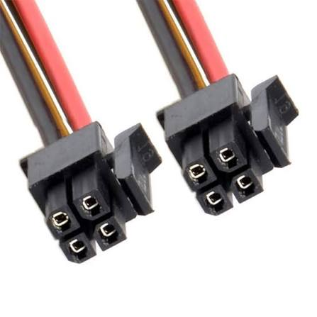
- Name: 4-Pin Molex Power Connector (Peripheral 4-pin)
- Devices Powered: Older IDE hard drives and optical drives, case fans, liquid cooling pumps, fan controllers, and legacy expansion cards.
- Safety Tip: The metal pins inside a Molex connector can easily wobble out of alignment; before plugging it in, inspect the four internal pins to ensure they are straight and centered, and avoid using cheap/molded Molex-to-SATA adapters which present a known short-circuit and fire risk.

4. PCIe Power Connector (6/8-Pin or 6+2 Pin) 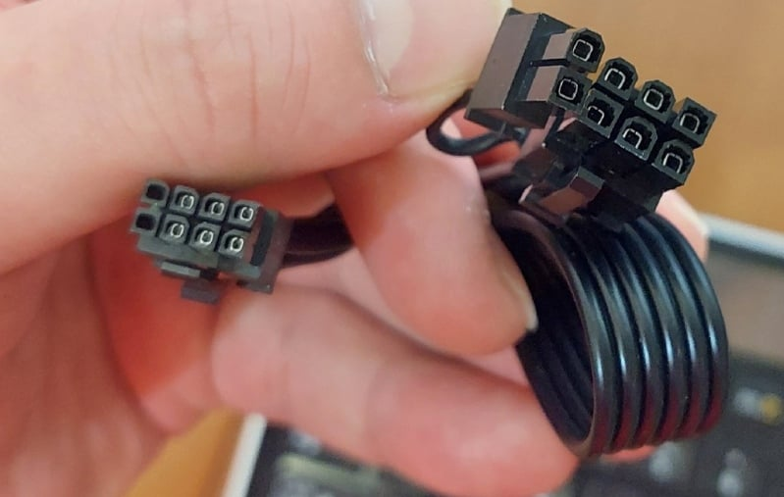
- Name: PCIe Power Connector (6-Pin / 8-Pin / 6+2 Pin)
- Devices Powered: Dedicated Graphics Processing Units (GPUs) / Graphics Cards and high-draw expansion cards (e.g., capture cards or RAID controllers).
- Safety Tip: Ensure the connector is pushed in until it makes a distinct "click" with the latch, and never substitute a 4+4 pin CPU power cable into a GPU's 8-pin PCIe slot—even though both have 8 pins, their wiring polarity is reversed and plugging the wrong one in will cause a short circuit or damage hardware.

- Imagine you are setting up a new gaming PC. List the steps you would follow to connect the SMPS to the motherboard, graphics card, and storage devices, mentioning which specific cables and connectors are used for each.

Step 1: Turn Off Power and Prepare the PC
- Ensure the SMPS power switch is in the OFF (O) position.
- Unplug the power cable from the wall socket.
- Wear an anti-static wrist strap or touch a grounded metal object to discharge static electricity.
- Arrange all SMPS cables so they are easy to identify.
Connectors used: None (Preparation step)

Step 2: Install the SMPS
- Place the SMPS into the power supply compartment of the PC case.
- Align the screw holes with the case.
- Secure the SMPS using the four mounting screws provided.
Connectors used: None (Mechanical installation)

Step 3: Connect the 24-Pin ATX Motherboard Power Cable
- Locate the 24-pin ATX connector from the SMPS.
- Find the matching 24-pin power socket on the motherboard.
- Align the connector using the locking clip.
- Push firmly until the clip clicks into place.
Cable Used: 24-pin ATX Power Cable
Purpose: Supplies the main power to the motherboard, RAM slots, chipset, PCIe slots, USB ports, and onboard components.

Step 4: Connect the CPU Power Cable
- Locate the 4+4-pin EPS CPU power cable (also called an 8-pin CPU connector).
- Connect it to the CPU_PWR socket near the processor.
Cable Used: 8-pin (4+4) EPS CPU Power Cable
Purpose: Delivers dedicated power to the processor for stable operation, especially during gaming and heavy workloads.

Step 5: Install the Graphics Card
- Insert the graphics card into the motherboard's PCIe x16 slot.
- Secure the card to the case using screws.
Connectors used: PCIe slot (mechanical installation)

Step 6: Connect PCIe Power to the Graphics Card
- Identify the required PCIe connector on the graphics card.
- Connect the appropriate 6-pin, 8-pin, or 6+2-pin PCIe power cable from the SMPS.
- Ensure the connector locks securely.
Cable Used: PCIe 6-pin, 8-pin, or 6+2-pin Power Cable
Purpose: Provides additional power required by dedicated graphics cards for gaming and graphics-intensive applications.

Step 7: Connect Power to SSDs and HDDs
- Locate the SATA power connectors from the SMPS.
- Connect one SATA power cable to each SATA SSD, HDD, or optical drive.
Cable Used: SATA Power Cable
Purpose: Supplies power to storage devices.
Note: A separate SATA data cable connects each drive to the motherboard.

Step 8: Connect Additional Accessories
If your PC includes extra components, connect them as needed.
Device | Power Connector Used
RGB/Fan Hub | SATA Power Connector
Liquid Cooling Pump | SATA or Molex Connector
Case Fans (older models) | Molex Connector
Fan Controller | SATA or Molex Connector

Step 9: Organize the Cables
- Route cables behind the motherboard tray.
- Secure them with cable ties or Velcro straps.
- Keep cables away from fans and airflow paths.
Purpose: Improves airflow, cooling performance, and ease of maintenance.

Step 10: Final Inspection
Before powering on the PC, verify that:
- ✅ 24-pin ATX cable is fully connected.
- ✅ 8-pin CPU power cable is securely attached.
- ✅ PCIe power cable(s) are connected to the graphics card.
- ✅ SATA power cables are connected to all storage devices.
- ✅ No loose cables are touching fans.
- ✅ All connectors are fully inserted and locked.

Step 11: Power On the System
- Connect the AC power cable to the SMPS.
- Switch the SMPS to ON (I).
- Press the PC's power button.
- Check that the motherboard, graphics card, storage devices, and cooling fans power on correctly.

